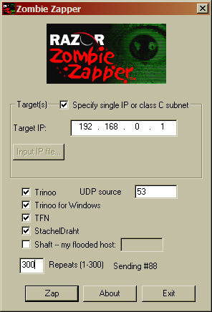

Summary
I think this program is useless. In my experience, unless you’re controlling the zombies, you can’t stop them. At all. And if you’re the target of a DDoS attack, there’s probably little you can do. Also, all of the zombies I’ve ever heard of are controlled via IRC (Internet Relay Chat) channels on unrelated IRC networks. At least the ones I’ve read about on Steve Gibson’s website were controlled via IRC.

